Linux Servers
Lab2 – Apache HTTP Server
Document your commands or take screenshots. Answer questions in english or finnish.
All configuration must be persistent (survive a reboot). You may use your own notes and Internet resources for your aid. You may consult the teacher or other students.
This lab will use the following topology:

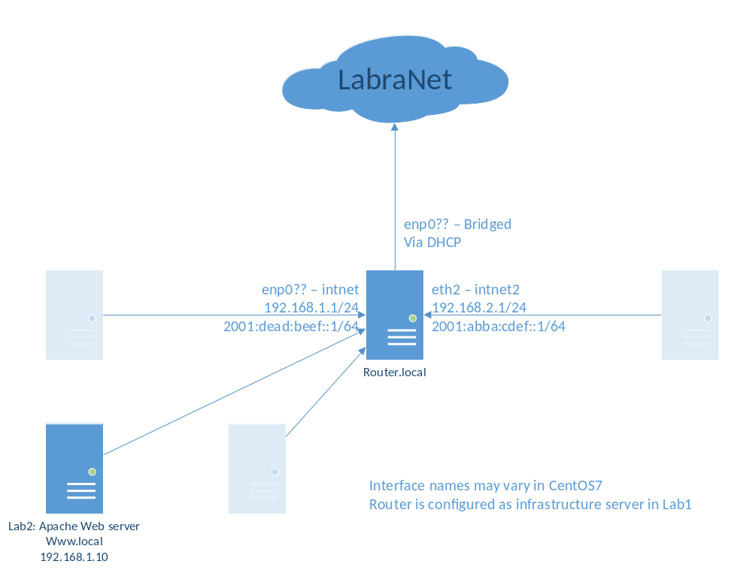

Apache installation (1p)
Install Apache (package and service name httpd), mod_ssl, Mariadb/MySQL server (mariadb-server, mariadb) and PHP (php, php-mysql). Turn on both httpd and mariadb-server -services. Add firewall rules for http and https traffic.
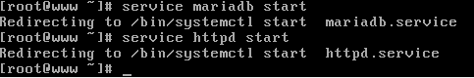

Sallitaan http ja https
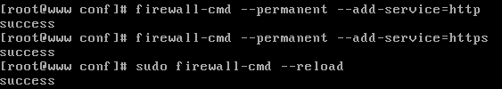
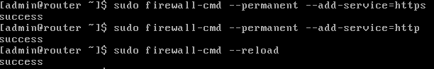
Laitetaan apache2 ja mariadb käynnistymään automaattisesti käynnistyksen yhteydessä:

Port forwarding rules (1p)
Create a port forwarding rule for the infrastructure server you made in Lab 1. Forward http and https ports to www.local. Use either firewallD or iptables depending on what you used in Lab1.
Port forward säännöt firewallD:
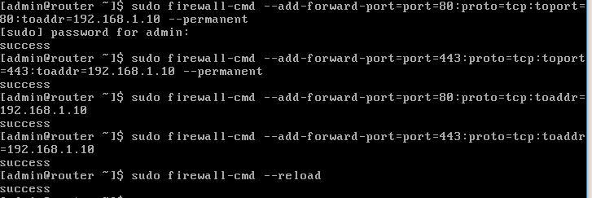

Basic hardening (1p)
Run mysql_secure_installation and define a root password for the database. Another options may be left for defaults.
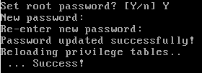
Turn off Apache default page (welcome page). Turn off sending of ServerTokens and ServerSignature. Disable indexing if it is on.
Kommentoin welcome.conffista seuraavat rivit:
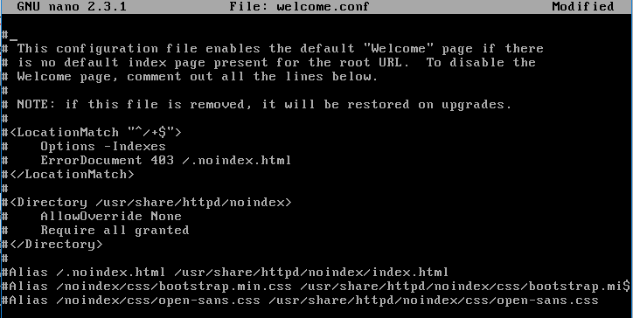
Laitoin httpd.conffiin asetukset:
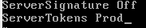
Poistin Optionsseista Indexing:
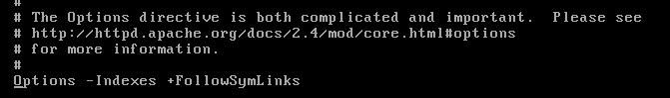
Create a redirect/rewrite rule that forces SSL to be used if the server is accessed via HTTP. (See Apache RedirectSSL or RewriteHTTPToHTTPS)
Samaan httpd.conffiin asetus:
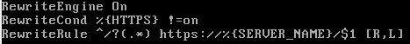

Pöytäkoneelta yhdistäessä tapahtuu redirect https:ään ja näyttää index.html:n
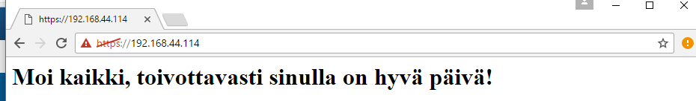

phpinfo and basic authentication (1p)
Create a directory /var/www/info and create a phpinfo page in there (examples in internet). Protect the directory with basic authentication (with login: test/test). Use .htaccess file (do not configure authentication directly in /etc/httpd/conf/httpd.conf, although you might have to modify this file also for AllowOverride).
NOTE: Do NOT put htpasswd -file anywhere in /var/www/html as this will make the file world-readable.
Tein info kansioon phpinfo.php tiedoston, jonka sisältö on:
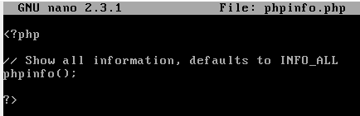
Tein info kansioon .htaccess ja .htpasswd tiedostot:
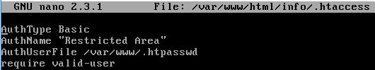
Siirsin .htpasswd /var/www kansioo
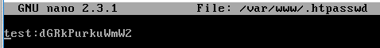
Httpd.conf:
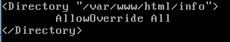

Wordpress installation (1p)
Install Wordpress from sources (wordpress.org link for tar.gz) to directory /var/www/html/wordpress. Use any installation guide you want.
Ennen wordpressin asennusta latasin php-gd modulen, että wordpress toimii kunnolla:
Purin ladatun tarin:
Siirsin puretun kansion var/www/html
Menin sivulle 192.168.44.114/wordpress
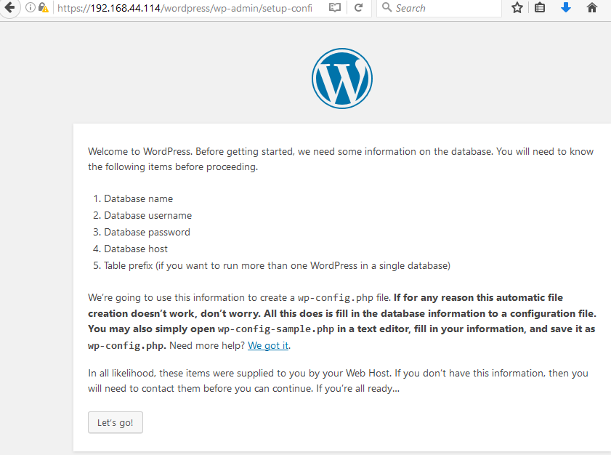
Konffasin mariadb databasee, tein sinne käyttäjän ja annoin sille oikeudet:
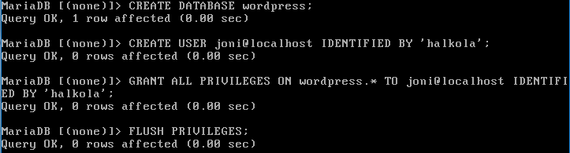
Conffataan wordpressiin database tiedot
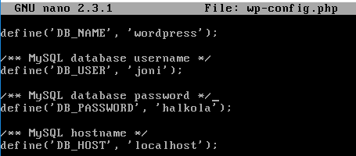
Viimeistellään asennus 192.168.44.114/wordpress sivulla:
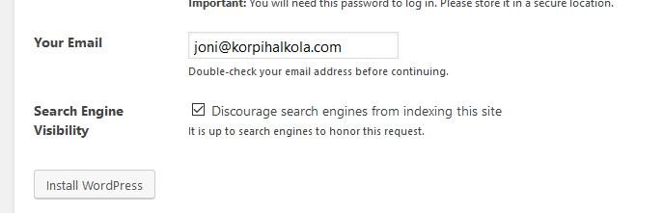
Take care of SELinux contexts (search wordpress SELinux). You need at least the following SELinux boolean:
httpd_can_network_connect_db
Sallitaan httpd to bind to port 80

Testing
Reboot www.local verify that your configuration persists. Test that you can access the server via the router LabraNet IP address (port forwards http and https to www.local).
Checklist for screenshots/documentation:
- Services are running after a reboot (systemctl status service)
Rebootin jälkeen:
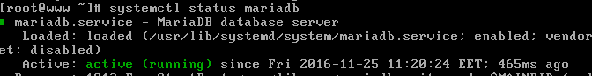
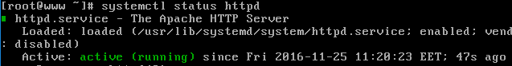
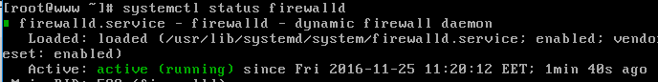
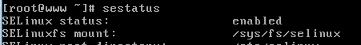
- Error pages show minimal information about the server
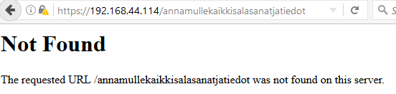
Viesti ei näytä palvelimen tietoja (eli esim Apache/2.2.22 CentOS Server)
- HTTPS is forced even if you access with HTTP
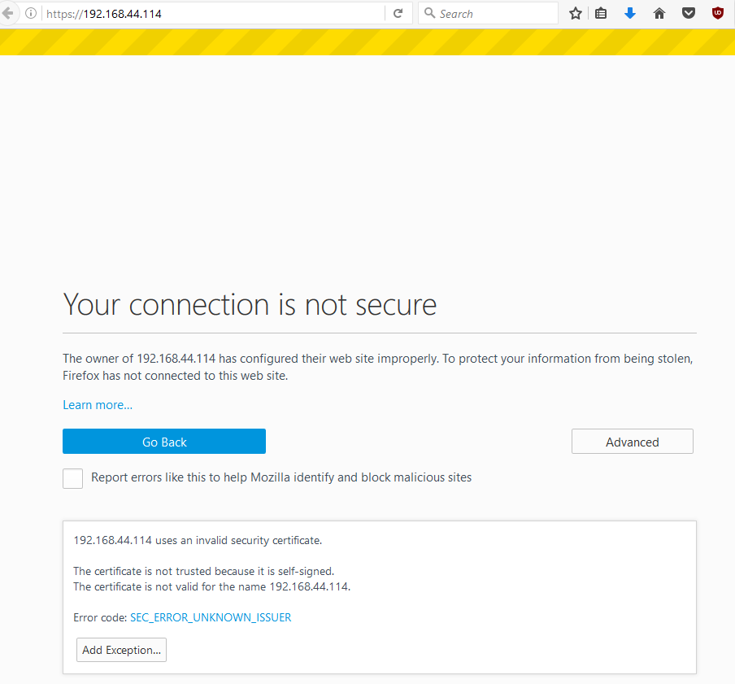
- /phpinfo shows PHP info page but after Basic Authentication login
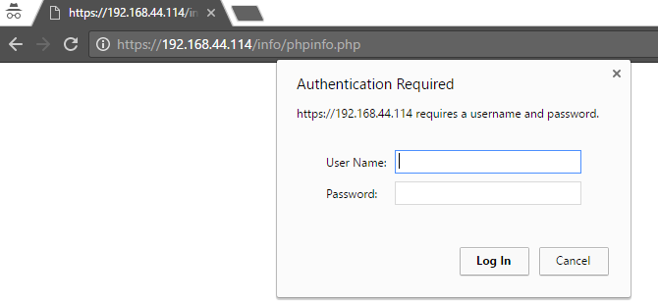
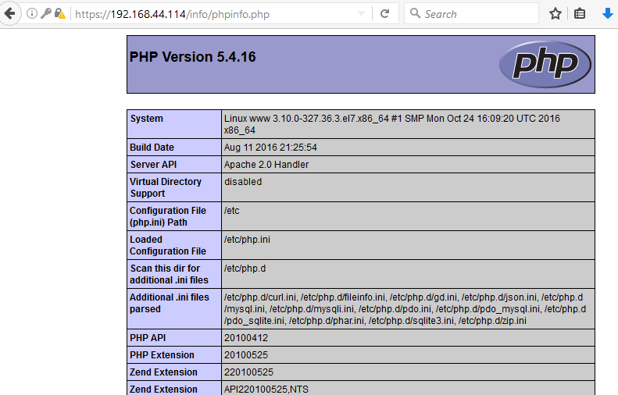
- /wordpress has a working instance of Wordpress installed
